This document introduces the commands that can be executed in the MATLAB **Command Window** to facilitate user operations.

# **Add DL PEL-HIL Blockset – addDL**

This command needs to be executed in MATLAB **after installing the DL PEL-HIL Blockset**, and it only needs to be run **once** after each installation or update of the Blockset.

The correct execution result is shown in the figure below. The command returns: ‘✅Successfully added DL Blockset‘. The status bar in the lower-left corner does not display ‘busy’ or any ongoing operation. The **Simulink Library Browser** starts automatically, showing that the **DL Library** has been added to Simulink.

# **Clean nonexistent directory - cleanPath**

After uninstalling a previous version of the DL PEL-HIL Blockset, starting MATLAB again may display numerous warnings about nonexistent paths. This command helps to clear these warnings.

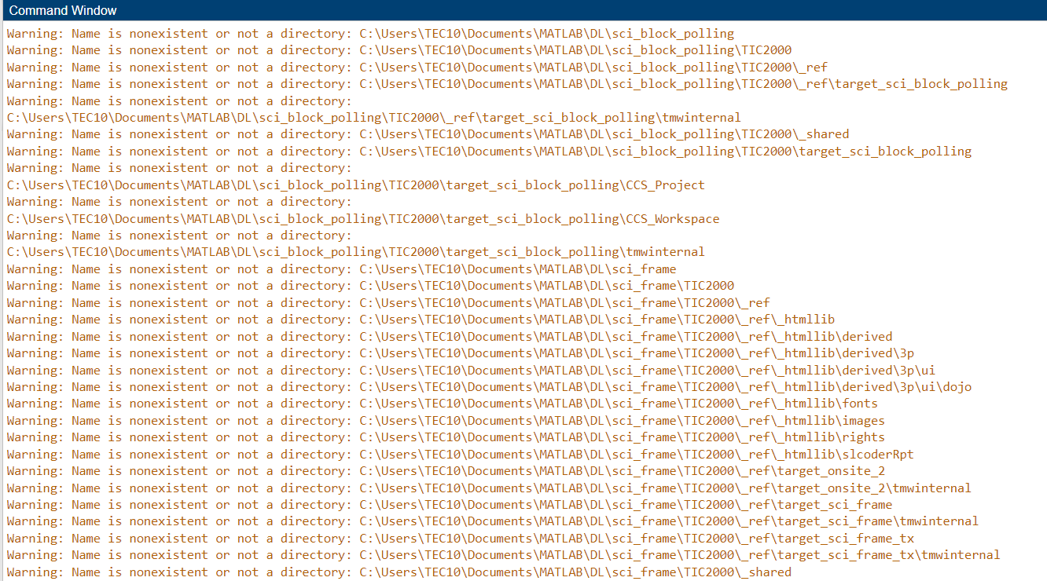

After executing **cleanPath** in the Command Window and restarting MATLAB, the command should return: ‘✅ All invalid paths removed and new path saved successfully.’ These warnings should disappear.

# **Create a new project - CreateNew**

This command helps the user create a new project.

💡 *It is recommended that each project has its own separate folder, and the folder path does not contain any spaces.*

Navigate the MATLAB working directory to the new project folder

Execute the **CreateNew** command in the MATLAB Command Window and enter the project name in the pop-up dialog box.

💡 *Avoid using special characters and spaces in the project name.*

Wait until the "Busy" status in the lower-left corner of MATLAB disappears, and no warnings or errors are displayed in the Command Window.

Two models are created by the system:

• **Target model**: This model will be compiled, deployed, and executed on the DL RCPCORE hardware. Its primary responsibility is to execute control algorithms and support real-time communication with the host model.

• **Host model**: This model runs on the PC in simulation mode. Its role is to debug parameters in the target model and display specific signals.

An **.m file** for setting parameters will also be generated automatically.

**Open a DL demo project – openDLDemo(‘xxx’)**

This command allows the user to browse and run demo projects provided by DL.

💡 *If changes are needed, we strongly recommend saving the project (target model, host model, parameter file) to the user’s folder instead of modifying the original project directly. To restore the project to its original state, the DL PEL-HIL Blockset needs to be reinstalled.*

If the available project names are unknown, you can try any name, and the command will automatically provide the available projects.

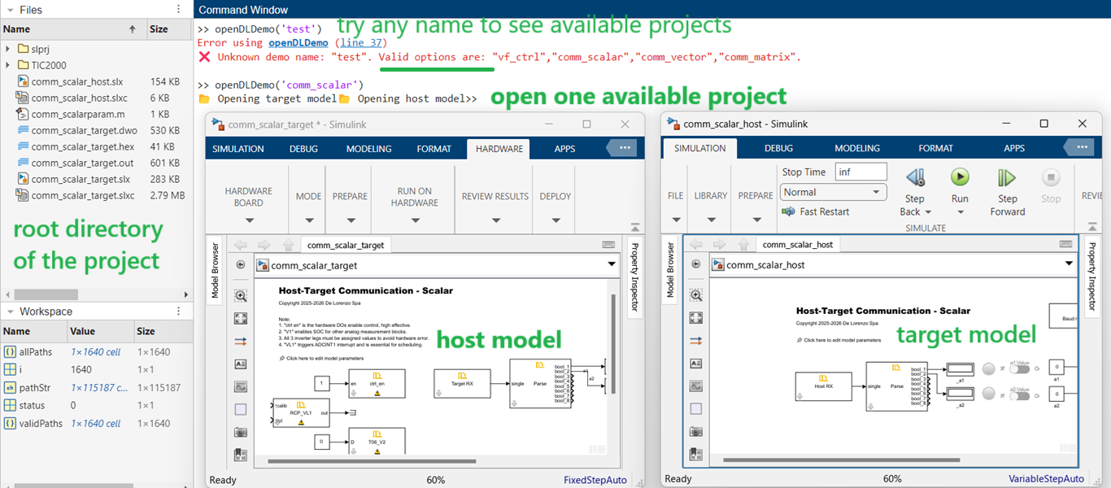

Save the following files to the user’s folder to copy the project.

